Navigate to https://killercoda.com/login
After sign in go to
https://killercoda.com/playgrounds/scenario/kubernetes

1- How many pods exist on the system?
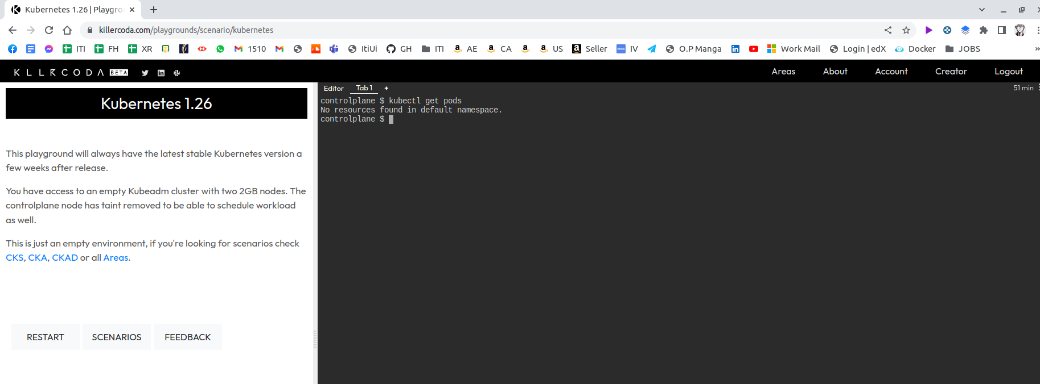

2- How many Nodes exist on the system?

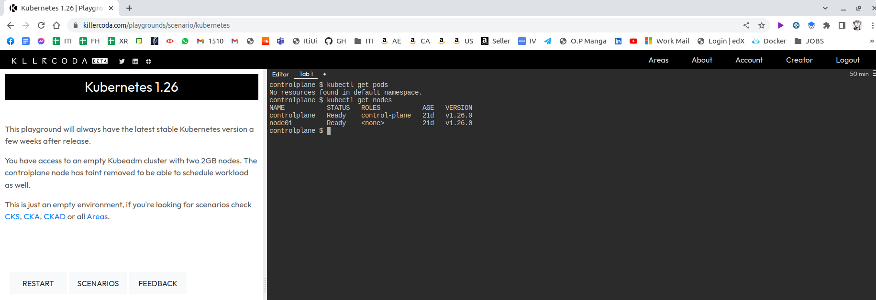

3- Create a new pod with the nginx image.
Image name: nginx
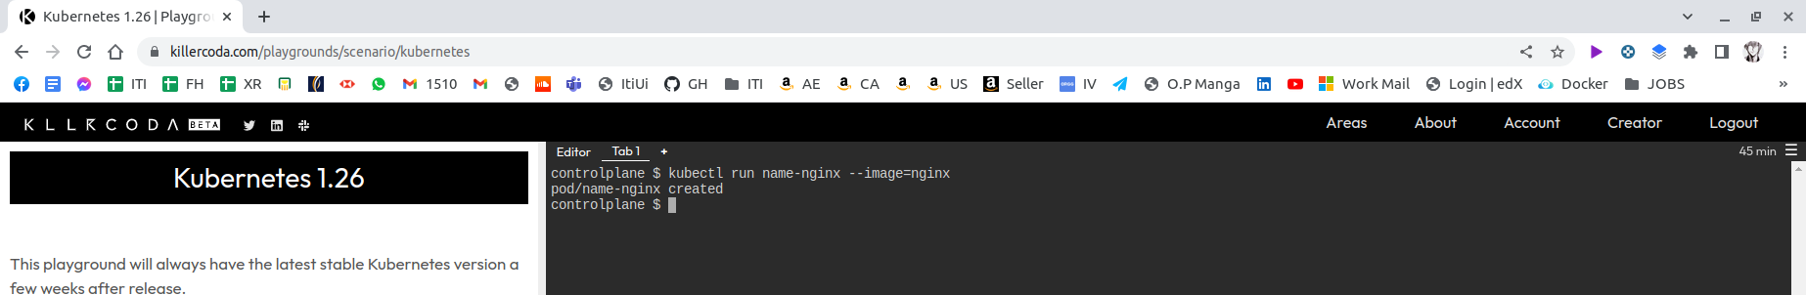

4- Which nodes are these pods placed on?
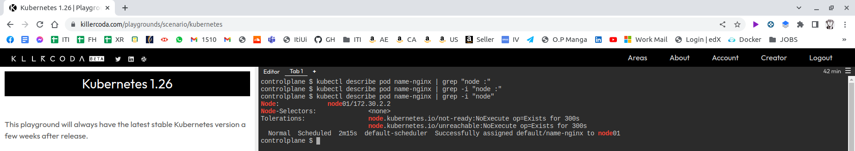

5- Create pod from the below yaml using kubectl apply command

apiVersion: v1
kind: Pod
metadata:
name: webapp
namespace: default
spec:
containers:
- image: nginx
imagePullPolicy: Always
name: nginx
- image: agentx
imagePullPolicy: Always
name: agentx
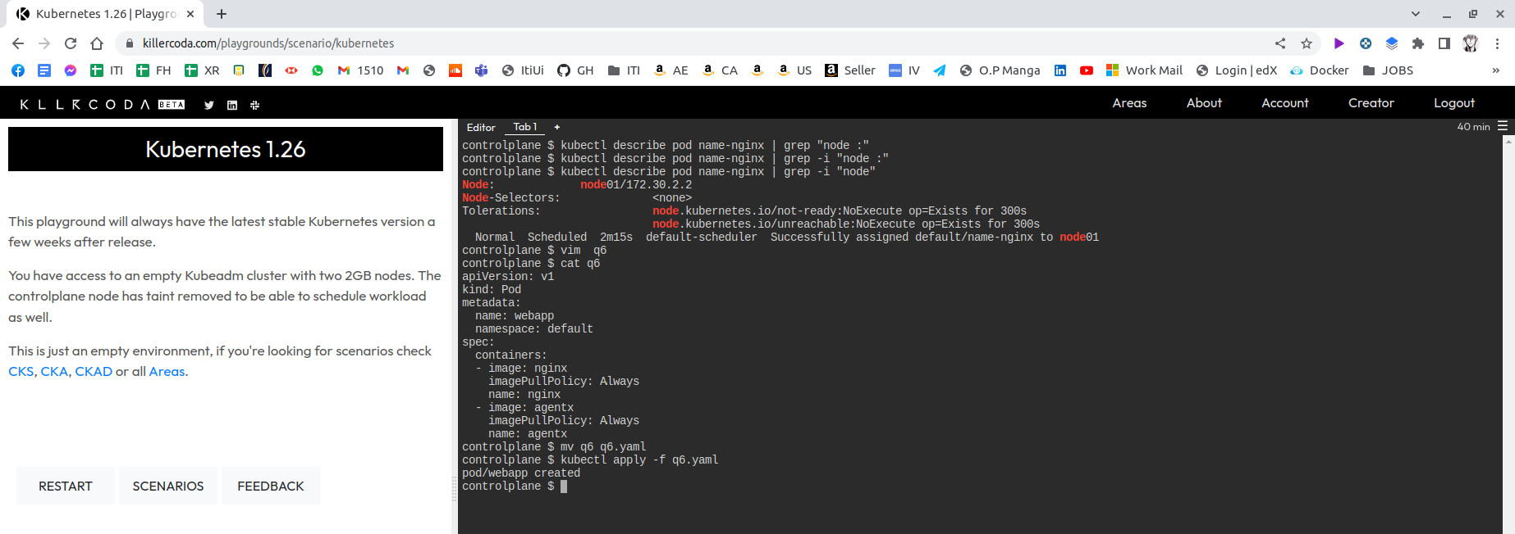

6- How many containers are part of the pod webapp
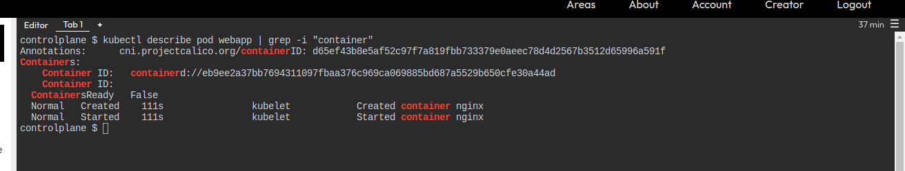

7- What images are used in the new webapp pod?
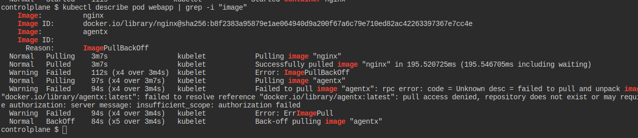
2 images

8- What is the state of the container agentx in the pod webapp
not ready
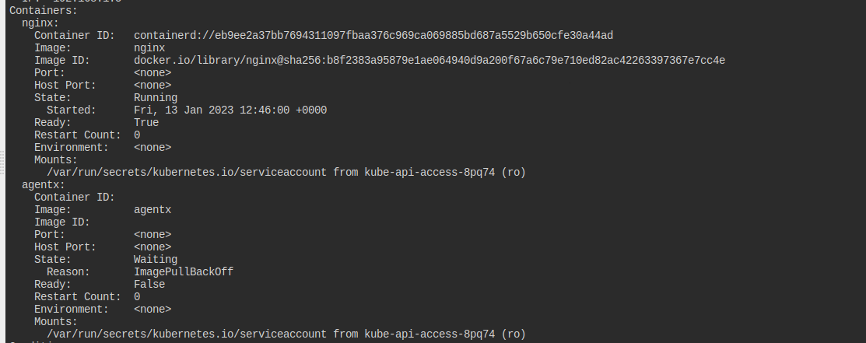
not ready

9- Why do you think the container agentx in pod webapp is in error?
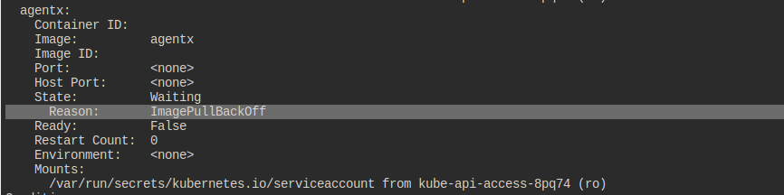
10- Delete the webapp Pod.
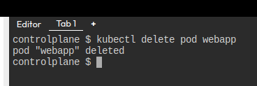
11- Create a new pod with the name redis and with the image redis123.
- Name: redis
- Image Name: redis123
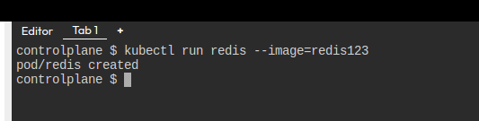

12- Now change the image on this pod to redis.
Once done, the pod should be in a running state.
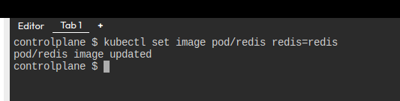

13- Create a pod called my-pod of image nginx:alpine

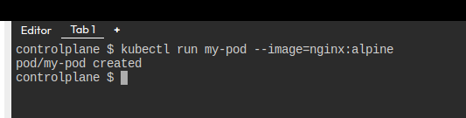
14- Delete the pod called my-pod
